Asg4 Bug 1 Log.

H0: Problem is in UI before returnBookControl.bookscanned(barcode) is called.

T0: Check bookbarcode – barcode is not correct i.e. not equal entered ID

R0: bookbarcode == entered ID

H0 is false - problem is not in UI before returnBookControl.bookscanned(barcode)

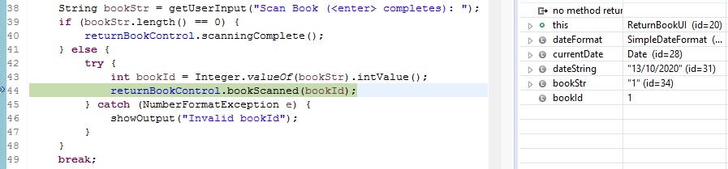

Simplication

H1: returnBookControl.bookscanned(barcode)